Using Elevation Offsets
The system lets you apply elevation offsets to the design to create target surfaces that are achievable in a single pass. You can also use a working surface offset to shift the design surface to a known distance above or below the design surface, for example a subgrade at a known distance below the finished level design. When using a working surface offset, elevation offsets are applied away from the working surface so you can work the offset down to zero over several passes to reach subgrade.
1. Access the Elevation Offset screen
The Elevation offset menu is accessible via two methods. Choose one method to access this screen:
Method 1
Press and hold the Elevation Offset button:
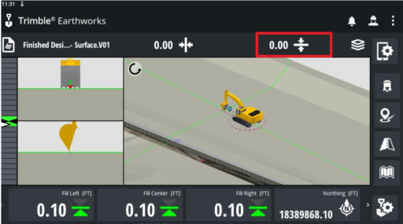
Method 2
Access the Work Settings menu and choose the Elevation Offset menu:
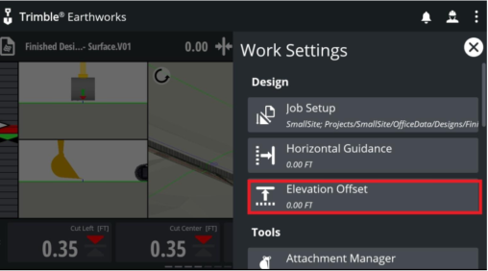
2. Enter the following data and then tap Apply:
- Offset value
- Select Focus point for guidance
- Offset direction (optional item under Advanced Options):
Vertical - typically for a known elevation
Perpendicular - typically for a known thickness, particularly on a sloping surface
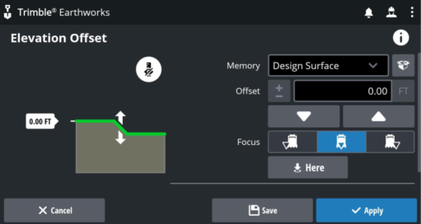
Offset values can be saved as Memories. These are accessible to the operator via tapping on the Elevation Offset field:
3. Open the work screen and tap the elevation offset field in the guidance bar to cycle through the saved offset memories.
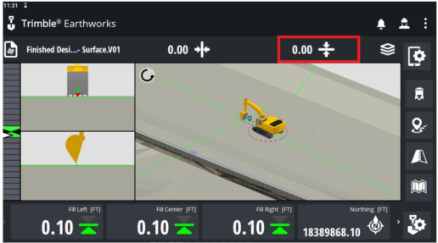
4. Use the increment/decrement elevation offset switch to increase or decrease the offset. (To edit the increment values, go to System Settings > Increments.)

